**NAME: Jagadeeswar Chimata**

**ID: 700731649**

**ML Assignment 4**

**Git hub link:** https://github.com/JagadeeswarChimata/Assignment-4.git

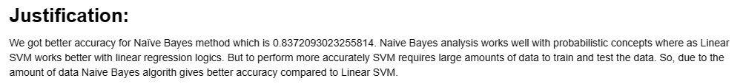

Git Hub link :